# Website feedback

1. **Reviews on Homepage**: Where are the reviews coming from? I do not see these on google

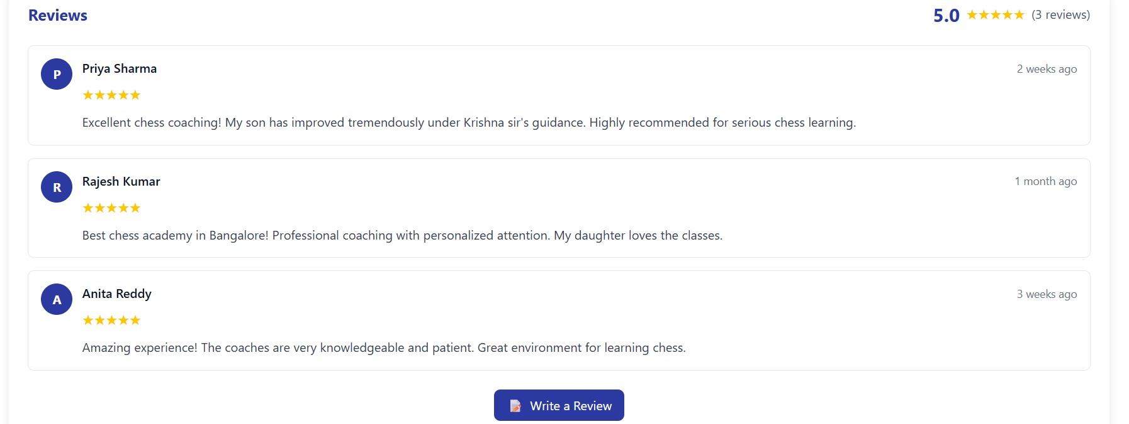

Also we have 2 centres – so reviews from both will be picked up?

1. Reviews on Homepage: When I click “write a review”, it goes to the link <https://www.google.com/search?q=ThinQ+Chess+Academy+JP%20Nagar>

It should navigate to <https://g.page/r/Cb3eufCaGw6TEAI/review>

1. Tournament registration is not showing the details

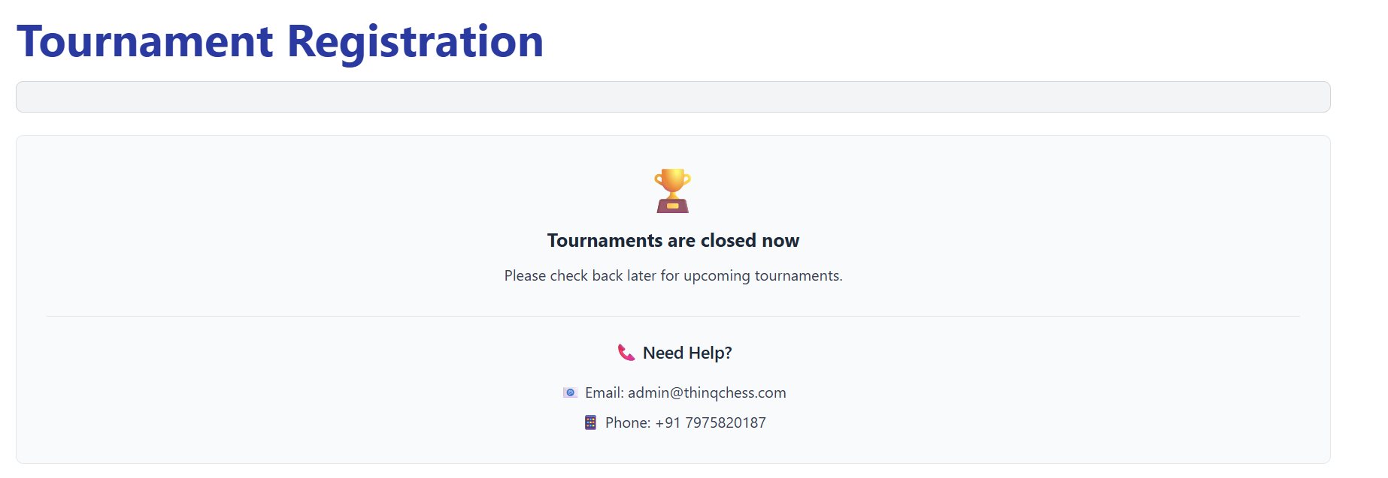

1. Book a demo scree: Phone number has –

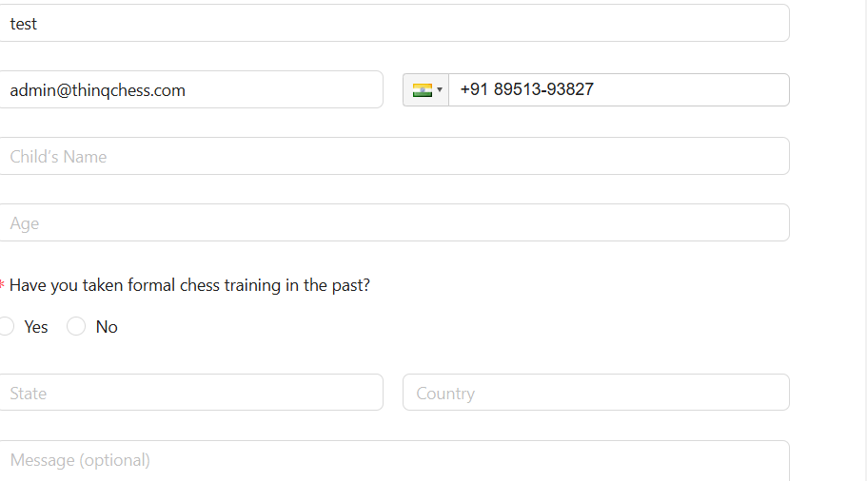

1. Book a demo: Tab does not work after phone number
2. Homepage: At ThinQ Chess section – change content – for children aged 5 years onwards



1. Homepage: Why choose Thinq Chess – reorder swap 3rd and 1st point.

Requested order is

1. Structured curriculum with measurable outcomes
2. Personalized attention through game-based coaching
3. Transparent tracking of student progress
4. Tournaments to build confidence
5. Encouraging and inspiring mentors

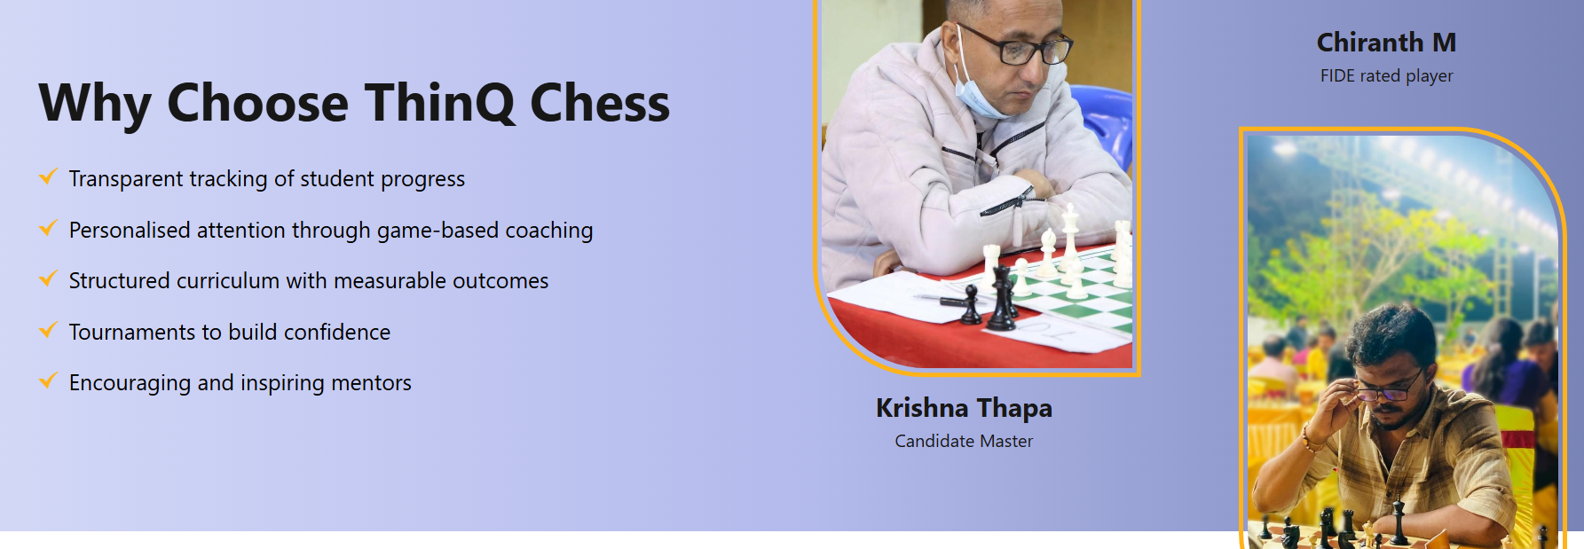

1. Website: Contact us page: Map should point to Thinq chess J P Nagar 8th phase. Also we have 2 centres. How do we handle this?

Instead it shows Anu provisions

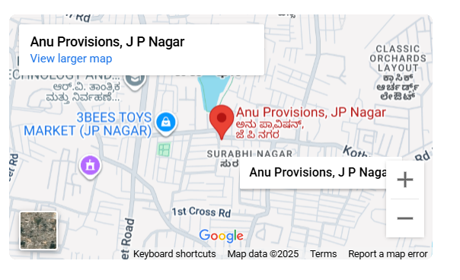

1. Website: Tournament registration – Hyphen shown for phone number

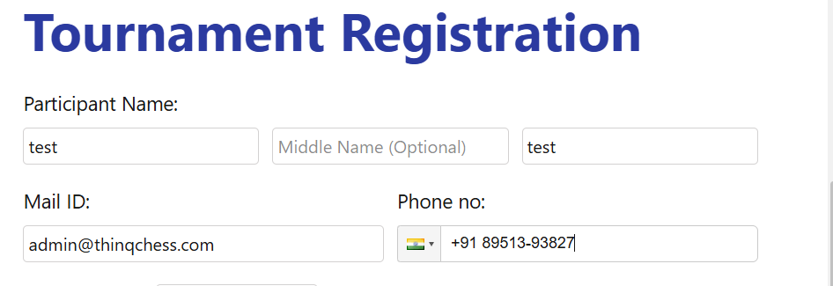

1. Homepage: Tournament registration

Validating discount code message is showing – not required.

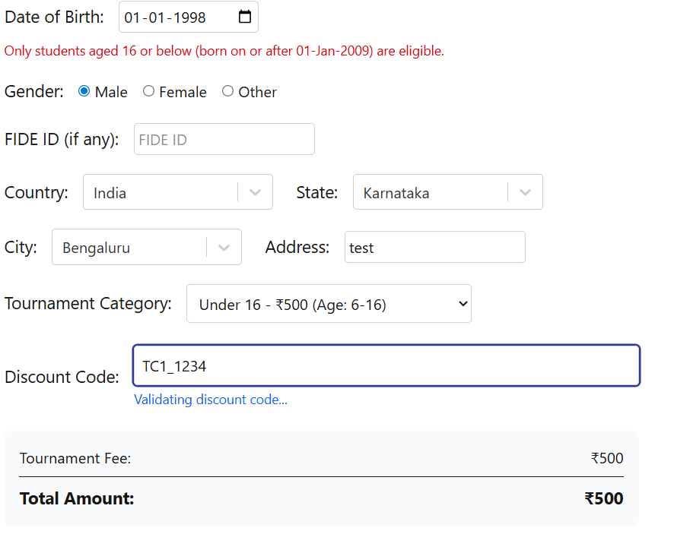

1. Homepage: Tournament registration page: Do a successful registration.

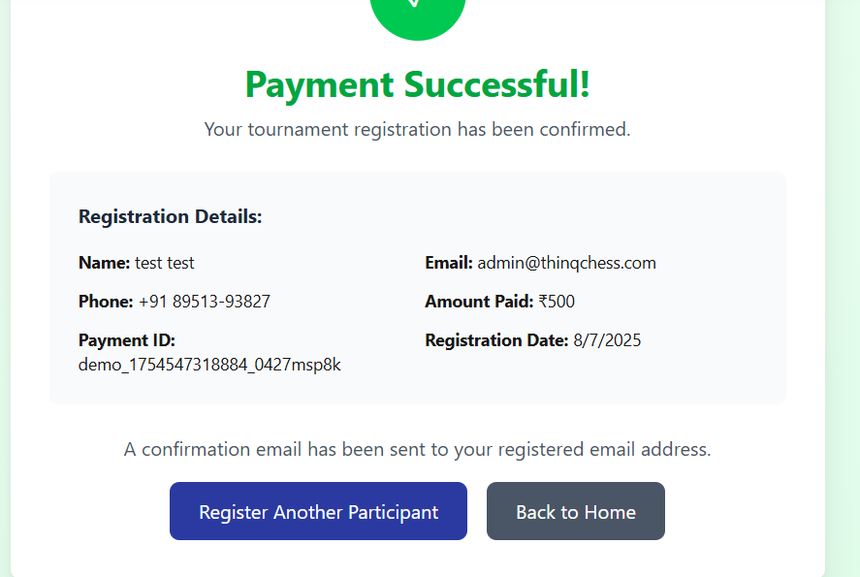

Click on “Register another participant”. The tournament registration page is shown. Scroll down.

Previously entered information remains. It should be cleared.

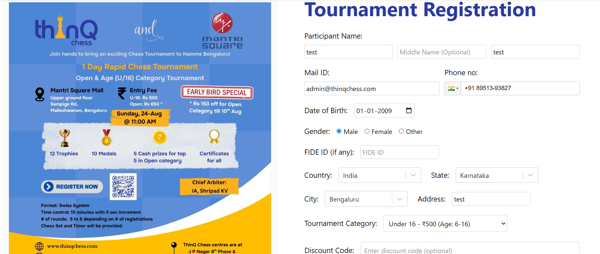

1. Admin: Tournament Management:

Clicked on Deactivate for the 24th Aug tournament.

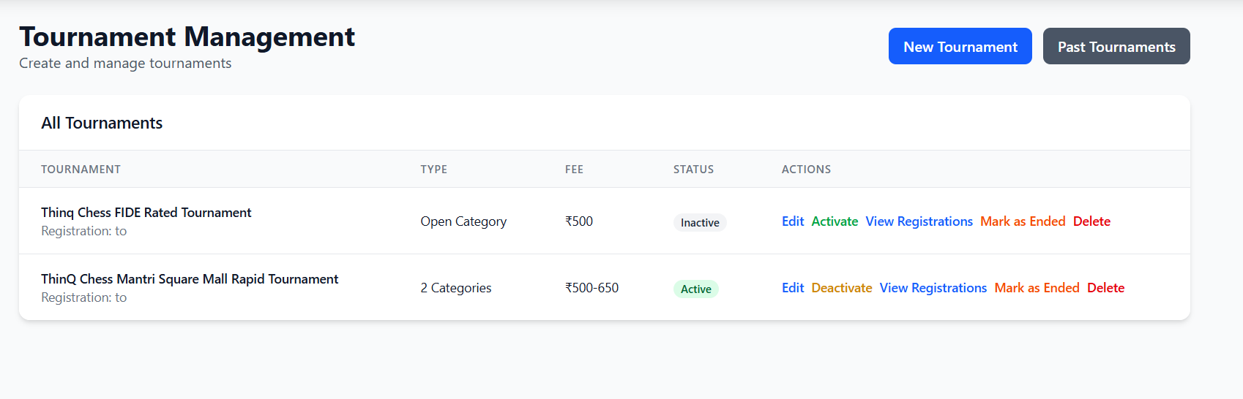

No change. What is the “Deactivate” option for? It is not working.

If I “Mark as ended”, the below screen is shown.

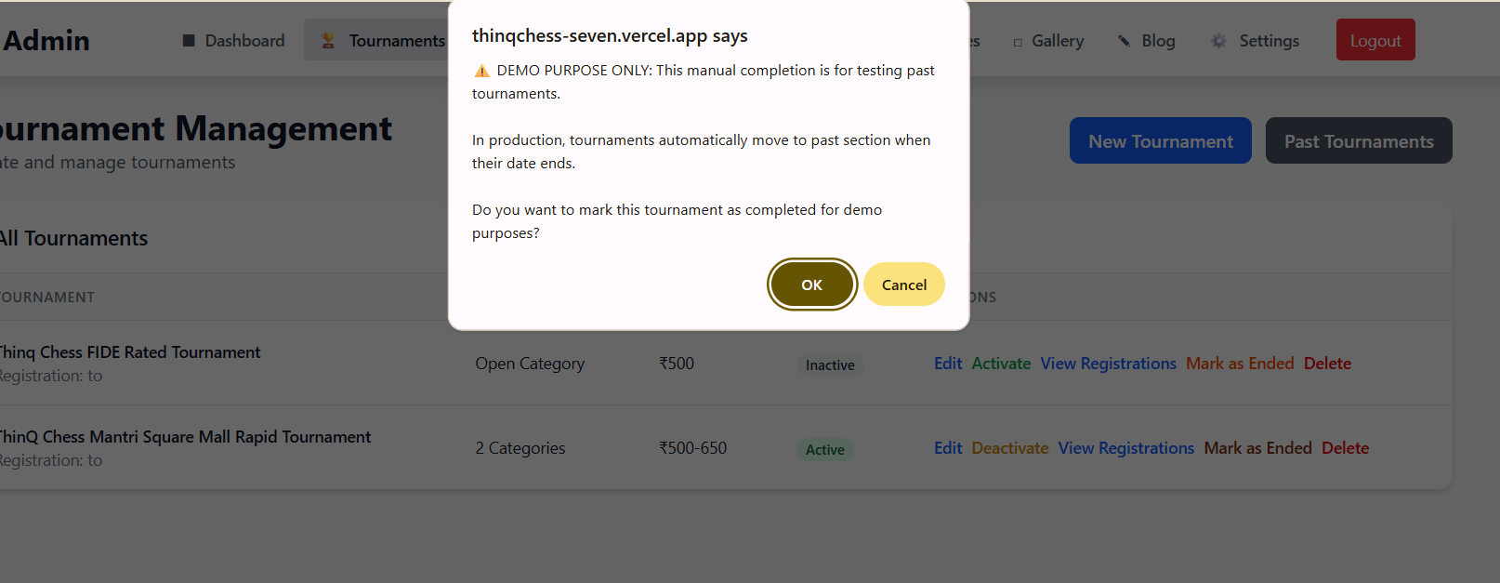

Clicked on “Ok”. Error updating tournament status

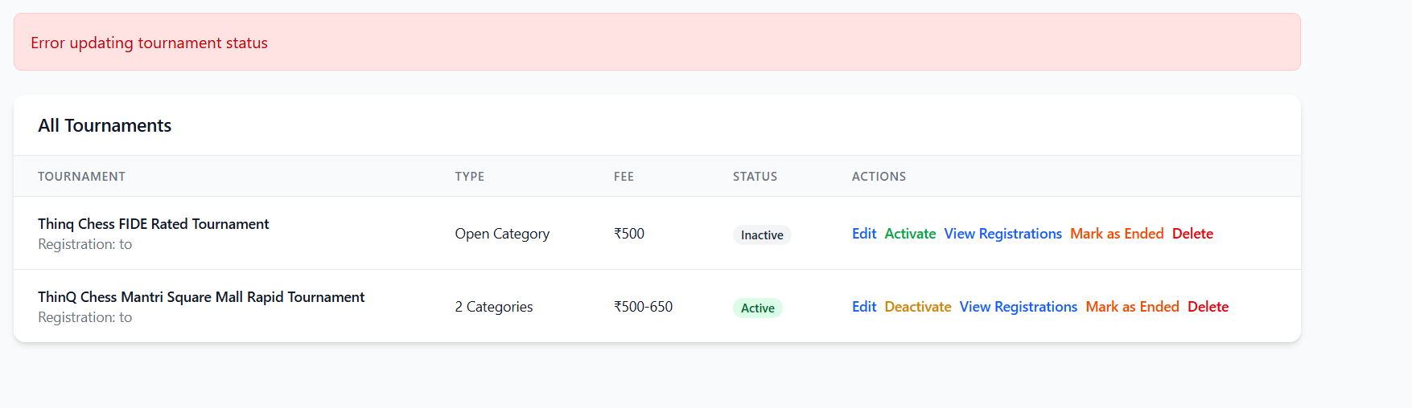

I clicked on “Delete for the Fide rated tournament – both tournaments got deleted!

1. Admin Dashboard: Tournament Management – The buttons should be “Save” & “Cancel”

Please change “Tournament”

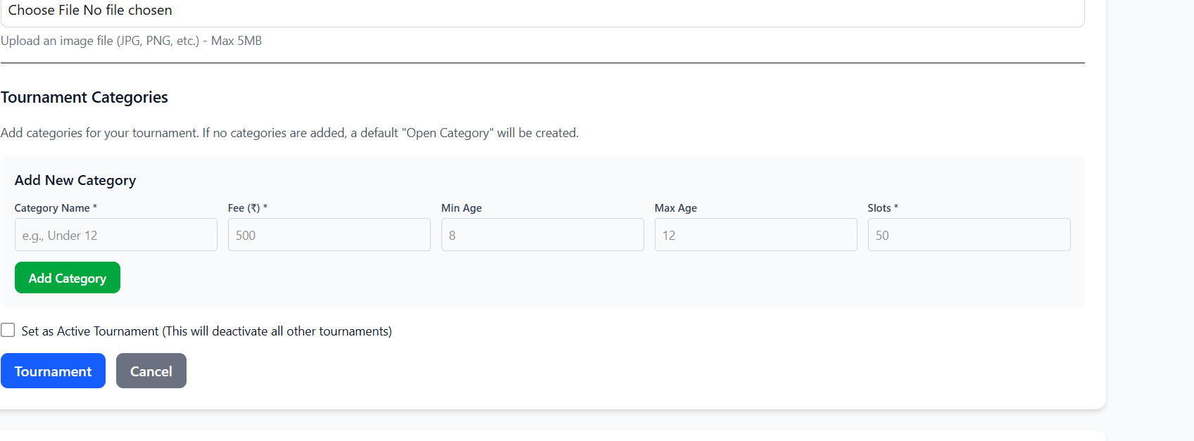

1. Admin Dashboard: Total registrations – I did a student registration and it is not showing in the count. Demo count is showing correctly.

**Admin dashboard @11:09 AM**

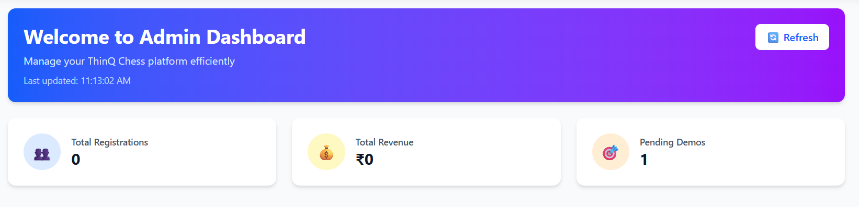

Does not change even after clicking on Refresh

**Registration email snapshot – 11:05AM**

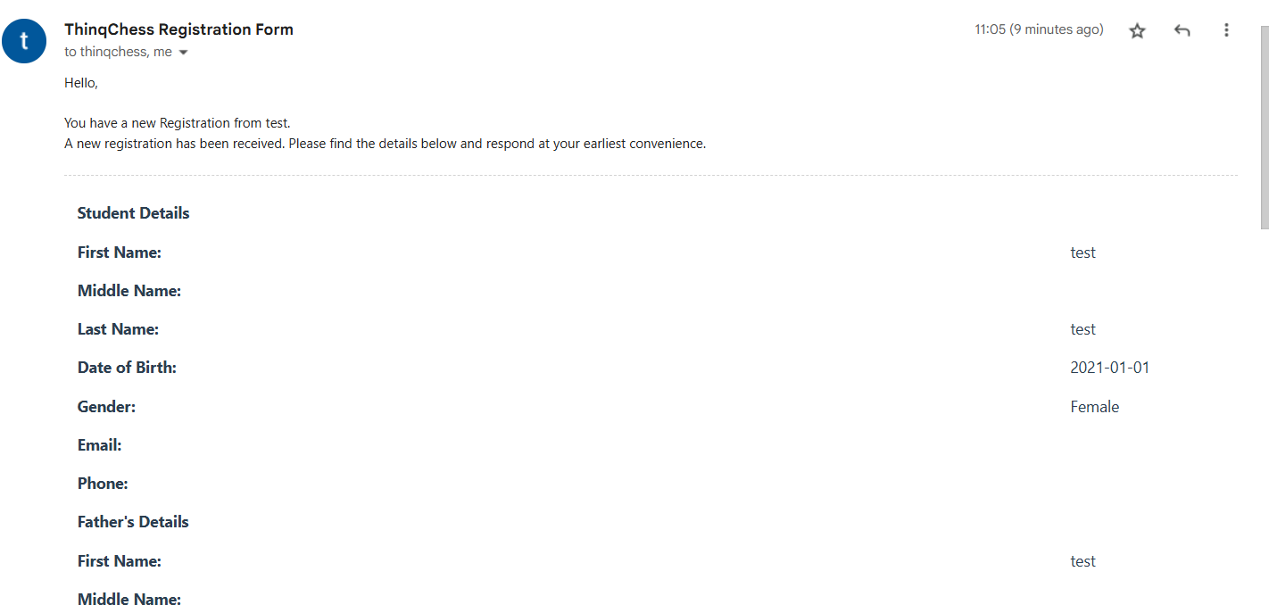

1. Tournament Management: Add New Category – When user enters Category name and fee and tabs, the screen refreshes and moves to the top. User has to scroll down to continue updating Min age etc

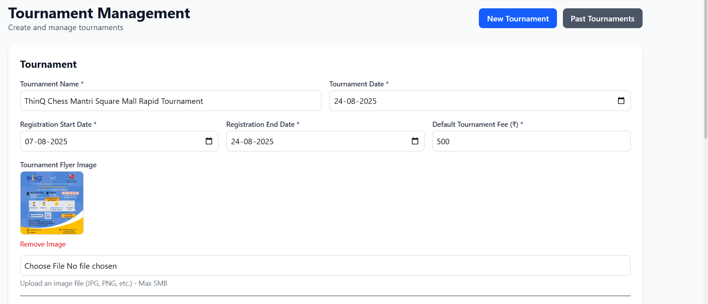

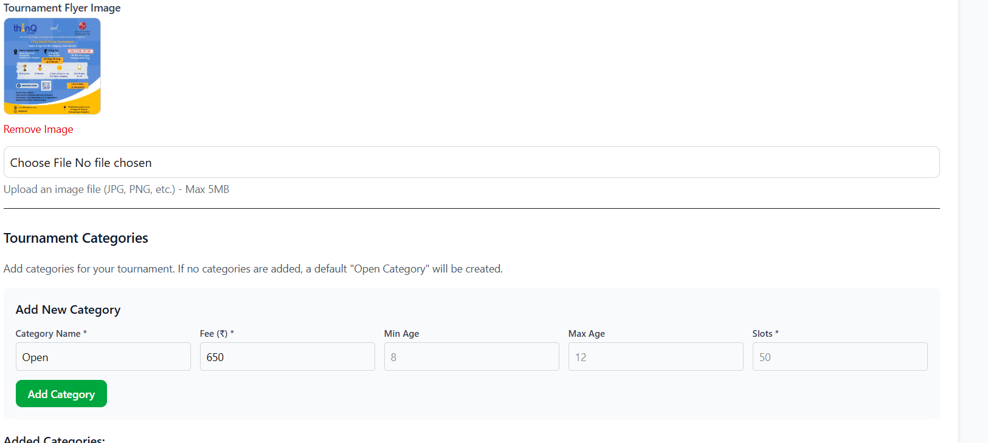

1. **Admin: Demo submissions – No demo registration is showing**

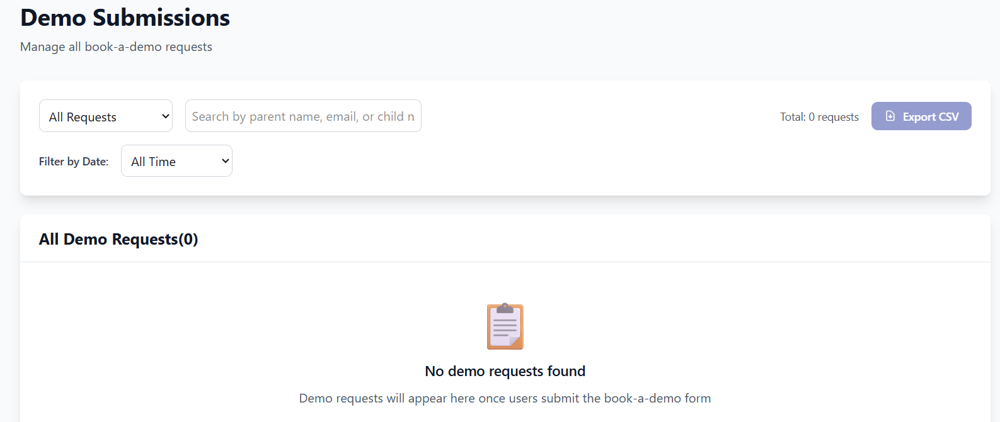

1. Prefix discount code is not working correctly

Ex: TC1_ should get 10% discount. But I need to also enter email name/prefix.

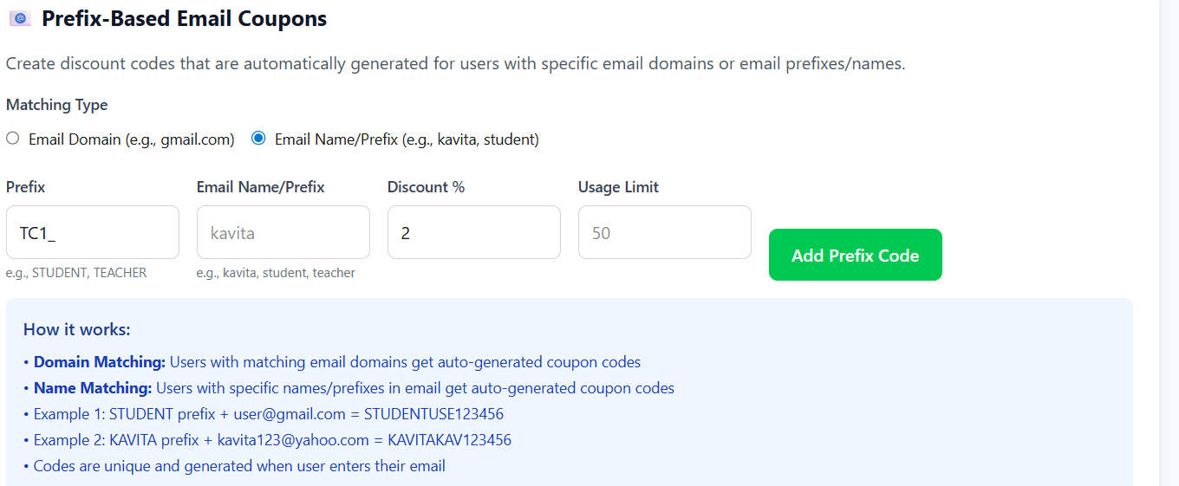

1. Tournament Management: Discount code issue – shared video